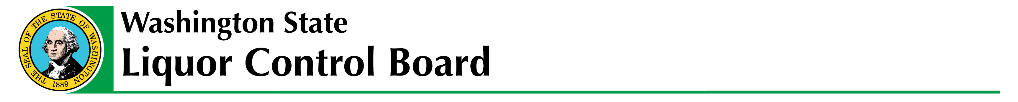

EMERGENCY RULES - #15-07

The Washington State Liquor Control Board filed Emergency Rules with the code Reviser’s Office to revise current recreational marijuana rules
The board approved emergency rules for WAC 314-55-010, WAC 314-55-017, WAC 314-55-018, and WAC 314-55-077. The rules become effective today June 10, 2015, and expire June 20, 2015, when the permanent rules adopted by the board become effective.

This notice can be found at http://www.liq.wa.gov/laws/laws-and-rules under Proposed Rules.

