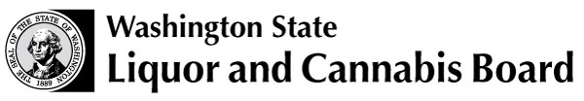 | Licensing and Regulation  1025 Union Ave SE  PO Box 43098  Olympia WA 98504-3098  Phone: 360 664-1600  Fax: 360 753-2710  www.lcb.wa.gov
 |  | License Number
 |  | Trade Name
 |  | UBI Number

REVOCATION OF AGENTS’ LICENSES

The person(s) named in the schedule below have ceased to be agents of and represent the undersigned firm:

Full Legal Name of Company or Corporation | License No. of Company
Company Address (Street or Route, City, State, Zip Code) | Telephone No.
Company Authorized Signature | Date
Email Address

Please print names.
If you have any questions or need assistance, please call (360) 664-1600 press option 1 then 2.

