 | 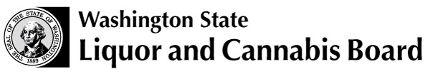 | Licensing and Regulation  1025 Union Ave SE  PO Box 43098  Olympia WA 98504-3098  Phone: 360 664-1600  Fax: 360 753-2710  www.lcb.wa.gov
 |  |  |  | License Number
 |  |  |  | Trade Name
 |  |  |  | UBI Number
APPLICATION FOR PRODUCT TRACKING CODE FOR  BEER, WINE LESS THAN 7% ABV OR CIDER NO GREATER THAN 8.5% ABV |  |  |  |  |  |  |  |  | DATE OF APPLICATION

TO BE COMPLETED BY BREWERY, WINERY, U.S. IMPORTER OR CERTIFICATE OF APPROVAL HOLDER
BRAND NAME |  |  | TYPE OF WINE, CIDER OR BEER (SUCH AS BURGUNDY, ALE, ETC)
MANUFACTURER/BOTTLER |  |  | PLACE WHERE MANUFACTURED |  |  |  |  | BONDED WINE NUMBER
CONTAINER SIZE/CASE CONFIGURATION |  |  | FOR WINE, CIDER OR BEER |  | ALC/VOL |  |  |  | ALC/WEIGHT
INSTRUCTIONS:  Submit one copy and retain a copy for your files. This form is to be used primarily for low alcohol wine, cider or Washington beer products that do not require label approval from the Tobacco Tax and Trade Bureau (TTB). |  |  | THE FOLLOWING COMPANY APPLIES FOR LABEL TRACKING FOR WINE, CIDER OR BEER FOR SALE IN THE STATE OF WASHINGTON.
SIGNATURE OF APPLICANT OR AUTHORIZED AGENT |  |  | CERTIFICATE OF APPROVAL OR LICENSE NUMBER

Phone Number:

Affix label below (if additional space is needed, label may be attached to the reverse side)

