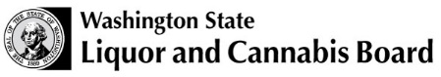
License Number
Trade Name
UBI Number

Affidavit of Cannabis Edible Product, Packaging, and Labeling Approval
I, , having been duly sworn upon oath, depose and say:
The following edible products, packaging, and labeling have been submitted and approved by the Liquor and Cannabis Board:
Product Name | Product Type | Product Flavor

For the products listed above, I have complied with the rules set in Chapter 246-70 WAC, which:
- Created independent standards for medically compliant products, including mandatory testing for:
  - Prohibited pesticides
  - Heavy metals
  - Mycotoxins
- Allows consumers the choice of compliant or regular products.
- Creates ratios for high CBD/low THC products that are sales tax-free for any adult.
In addition, the following logo requirements have been met:
- The logo can be no smaller than 1/2 inch round.
- The logo may only be printed in black or blue.
- The logo must be readily visible by the consumer.

Licensee (Print Name) |  |  | Title
Phone Number |  |  | Email
Licensee Signature |  |  | Date

