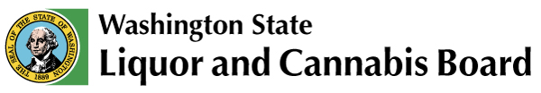 | Licensing & Regulation  1025 Union Ave SE  PO Box 43098  Olympia, WA 98504-3098  Phone: 360-664-1600  Fax: 360-753-2710  www.lcb.wa.gov
 |  | License Number
 |  | Trade Name
 |  | UBI Number

Kitchen Rental Acknowledgment

I understand and agree to follow the requirements below when renting out my kitchen space to a food business for the purpose of food preparation and cooking:

- All alcohol on the premises must be secured (in a locked compartment) or removed during the hours the renter is using the kitchen. If alcohol is removed, the licensee must inform their local LCB Liquor Enforcement Officer.

- A standard operating contract must be maintained that excludes any profit sharing with the renter.

- The renter does not have ownership in any liquor-licensed business.

- The renter must take the final food product out of the liquor-licensed location and may not serve customers at the liquor-licensed location.

- The renter may only cook and prepare food when the liquor-licensed location is closed for public service.

I certify by my signature below that I currently meet and will continue to maintain the above requirements as long as I rent out the kitchen space of my liquor-licensed premise.

Print Name | *
Signature | (*If you are printing this form select your title: Corporate President, Corporate Vice President, Corporate Secretary, Corporate Treasurer, Corporate Shareholder, LLC Member/Manager, Sole Proprietor, Partner or Spouse.)
Date

