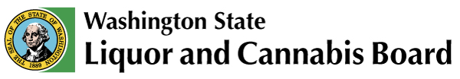 | Licensing & Regulation  1025 Union Ave SE  PO Box 43098  Olympia, WA 98504-3098  Phone: 360-664-1600  Fax: 360-753-2710  www.lcb.wa.gov
 |  | License Number
 |  | Trade (Business) Name
 |  | UBI Number

Acknowledgment of Requirements
Co-Operating Off-Site Tasting Rooms and/or Shared Tasting Areas
I understand and agree to follow the requirements below when co-operating a winery additional location with a distillery off-site tasting room location, or any combination thereof:

- May only sample, serve, and sell products authorized under the terms of your own license.

- Must maintain separate storage of products and separate financials from other licensees.

- Must share staffing resources with co-operating licensees.

- All participating licensees will be jointly responsible for any violation or enforcement issues unless it can be demonstrated that the violation or enforcement issue was due to one or more licensee's specific conduct or action.

Shared Tasting Areas

I understand the requirements above and the requirement below must be followed when sharing a tasting area with a winery, brewery, or distillery.

- Each licensee must use distinctly marked glassware or serving containers. Markings on glassware and serving containers may be permanent or temporary.

I certify by my signature below that I currently meet and will continue to maintain the above requirements as long as I/we co-operate a location.

Print Your Name | *
Signature | (*If you are printing this form select your title: Corporate President, Corporate Vice President, Corporate Secretary, Corporate Treasurer, Corporate Shareholder, LLC Member/Manager, Sole Proprietor, Partner or Spouse.)
Date

