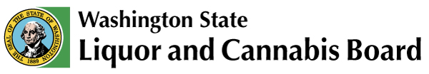 | Licensing & Regulation  1025 Union Ave SE  PO Box 43098  Olympia, WA 98504-3098  Phone: 360-664-1600  Fax: 360-753-2710  www.lcb.wa.gov
 |  | License Number
 |  | Trade Name
 |  | UBI Number

Distillery Tasting Room Food Service Acknowledgment

I understand the following food service requirements must be met when offering servings or tastings to obtain and maintain a craft distillery, distiller/rectifier, or fruit and/or wine distiller liquor license:

- Provide food offerings to customers during public service hours for free or for a charge. May include a mix of hors d’oeuvre type foods, cheeses, fruits, vegetables, deli-style meats, chips, pretzels, nuts, popcorn, crackers, or other similar items.

- Post a list of at least five local restaurants or food trucks in a conspicuous place within any tasting room. The list must include the name, address, contact information, and hours of operation for each location.

- Allow customers to bring food for consumption into the distillery tasting room.

I certify by my signature below that I currently meet and will continue to maintain the above requirements as long as I/we hold a Craft Distiller, Distiller/Rectifier, or Fruit and/or Wine Distiller liquor license.

Print Name | *
Signature | (*If you are printing this form select your title: Corporate President, Corporate Vice President, Corporate Secretary, Corporate Treasurer, Corporate Shareholder, LLC Member/Manager, Sole Proprietor, Partner or Spouse.)
Date

