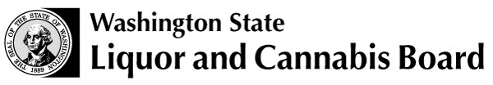 | Licensing and Regulation  1025 Union Ave SE  PO Box 43098  Olympia WA 98504-3098  Phone: 360 664-1600  Fax: 360 753-2710  www.lcb.wa.gov
 |  | License Number
 |  | Trade Name
 |  | UBI Number

MOTEL GUEST STATEMENT OF DECLARATION AS REQUIRED
BY RCW 66.24.540 AND WAC 314-02-080

I understand that I am subject to a fine and/or imprisonment for any false statement made on this form.

I have presented legal proof of age indicating that I am twenty-one years of age or older.

No one under twenty-one years of age will have access to the liquor in the honor bar.

Print Name |  | Signature
Date and Time |  | Address

I certify and declare under penalty of perjury of the laws of the state of Washington that the above declarations are true and correct. I am aware that the penalty for furnishing liquor to persons under 21 years of age is a fine of up to $500 and/or 60 days in jail. I am aware that any misrepresentation of fact may result in a criminal charge punishable by time in jail and/or a fine.

