Guidance Sheet: False or Misleading Statements Concerning Cannabis Infused Products

Policy Statement Number: PS21-05

Effective Date: September 30, 2021

Statutory Authority:
RCW 66.24.150(3)(d) provides that holders of a license to manufacture liquor may not mix or infuse THC, CBD, or any other cannabinoid into any product containing alcohol.

RCW 69.50.346 describes required labeling content for all cannabis concentrates, usable cannabis, or cannabis-infused products sold at retail.

RCW 69.50.346(3)(a) provides that labeling for cannabis concentrates, usable cannabis or cannabis infused products may not be false or misleading.

Regulatory Authority:

WAC 314-55-077(6) Describes the Board’s approval process and requirements for cannabis recipes, products, packaging and labeling.

WAC 314-55-105 describes cannabis product packaging and labeling.

Policy Summary:

- Product labeling is false or misleading in any particular way.
This could include but is not limited to unsubstantiated claims, claims that cannabis has curative or therapeutic effects, or claims that are deceptive or untruthful.
- The product is offered for sale under the name, identity or characteristics of another food or beverage or mimics another food or beverage, or the characteristics of another food or beverage, such as an alcohol product.
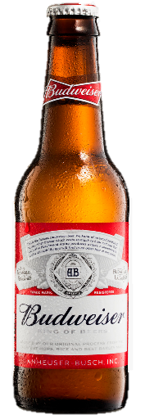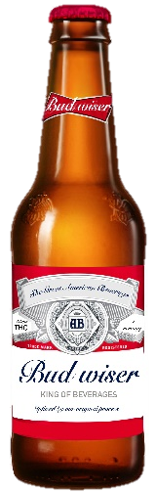 | This design mimics a commercial brand of alcohol. It could be mistaken for an alcohol product therefore increasing the risk of accidental exposure to cannabis.
 | Left: | Actual alcohol label
 | Right: | A cannabis-infused, liquid edible
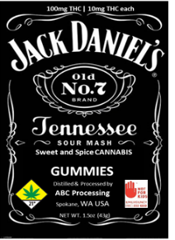  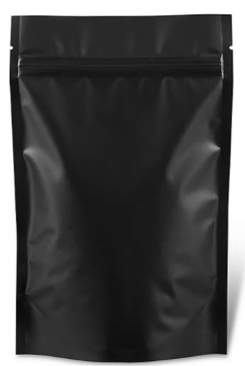  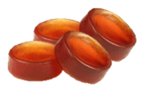 | This solid, infused edible label mimics a commercial brand of alcohol. Food misbranded is a false or misleading representation with respect to another food, drug, device, or cosmetic. Rule prohibits packaging and labeling from being false or misleading.
 | Left: | Actual alcohol label
 | Right: | A cannabis infused solid edible label design
- The product is an imitation of another food or beverage, unless the label bears, in type of uniform size and prominence, the word “imitation” and, immediately thereafter, the name of the food or beverage imitated.
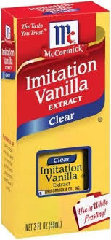  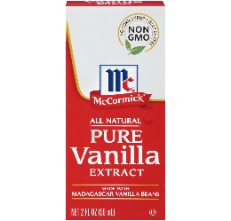 | Real vanilla extract is made by soaking vanilla pods in alcohol. Imitation vanilla is made with vanillin (the flavor compound that makes vanilla taste like vanilla), which is synthesized in a lab. Both are called vanilla with the imitation labeled as such.
- If its container is made, formed or filled as to be misleading (for example, shaped like a martini glass or champagne bottle).
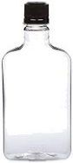  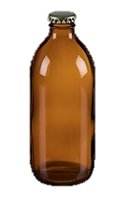 | While a container can be used for multiple types of products, there are those that are commonly associated with alcohol products. Using a container of this type increases the risk of it being mistaken for an alcohol product therefore increasing the risk of accidental exposure to cannabis.
- If the packaging, labeling, or both, of a liquid or solid cannabis product contain an image or images of alcohol glasses or bottles.
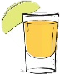  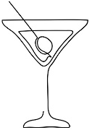  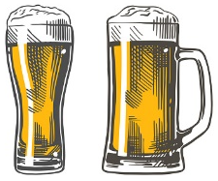 | Designs and layouts containing an image or images either of a glass or bottle commonly associated with alcohol can be misleading. Such as but not limited to a photographic image, an abstract design, or line art.

