**Expanded Alcohol Services Site Map Guidelines**

A site map is required for all indoor and/or outdoor expanded alcohol service events. A site map designates all alcohol service areas and points of sale, to include dimensions of the area, capacity, number of alcohol service/security employees staffing the area, and what type/size of barrier will surround the alcohol service area.

Please submit a site map that includes the following:

* Shared outdoor and/or indoor service area and the location of participating licensees, including caterers and nonprofits utilizing a Civic Campus and/or Fan Zone Special Occasion License.
* Location of barriers and all public entrances (must describe access, such as street, alley, parking lot, and list street names).
* Clearly identify alcohol serving areas/Point of Sale (POS) locations.
* North arrow indicator.
* Location of structures, fire lanes, streets, alleys, fencing (indicating location of exits and gates).
* Location of tents or temporary structures, including dimensions.
* Vendors, food trucks, merchandise areas.
* Stage location and sizes.
* Facility level (if applicable).
* Any other pertinent details related to the event area.

The site map can be hand-drawn, as long as the requirements listed above are all met.

If you have questions, please email [ExpandedAlcoholServices@lcb.wa.gov](mailto:ExpandedAlcoholServices@lcb.wa.gov).

**Key Example**

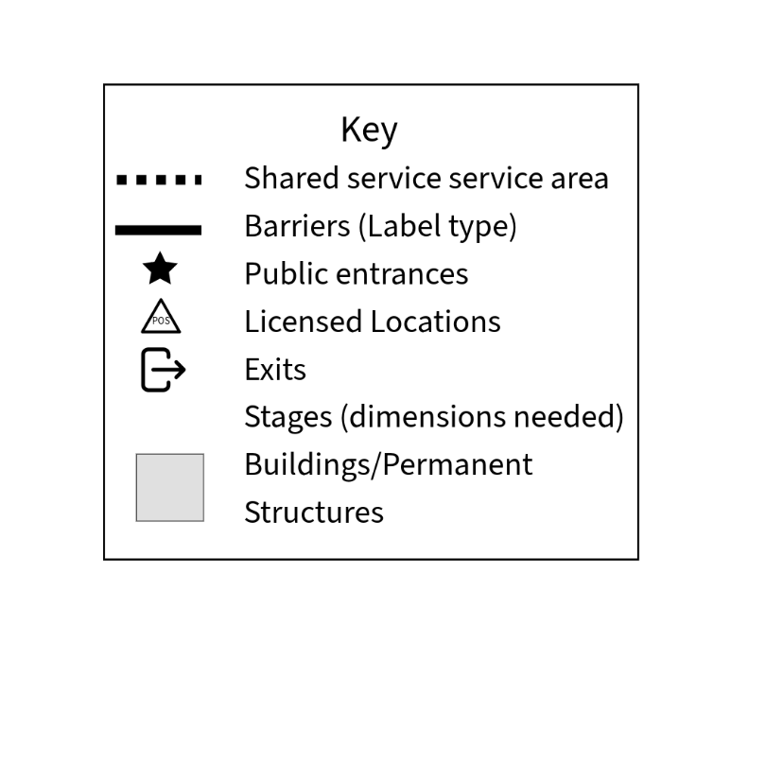

**Site Map Example**­

