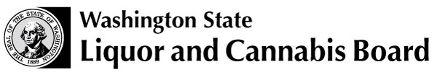 |  | Licensing and Regulation  PO Box 43098  Olympia WA 98504-3098  LicensingChanges@lcb.wa.gov

WASHINGTON RETAILER REQUEST DISCONTINUE OF ENDORSEMENT FOR OUT OF STATE DIRECT PURCHASES

WSLCB License #

Licensee Trade Name

Address
Street, Route, PO Box, City, State, Zip Code

This document is sent as a formal request for assistance to cancel the endorsement attached to our liquor license that permits us to receive beer / wine / spirits from Out Of State Suppliers.

This endorsement has not been utilized. Beer / Wine / Spirit product has never been received directly from an out of state supplier.

This endorsement is no longer needed. Retail licensee will no longer purchase Beer / Wine / Spirit product from out of state supplier.

Discontinue direct shipments outside of Washington & continue in-state shipments only

Request to have this endorsement removed from our liquor license certification.

Should you have questions I may be reached at: | ( ) -

Date:
Title:
Print Name:
Signature:

