Supplier Inventory Buyback Agreement between the Washington State Liquor Control Board and Insert Supplier Name

The Washington State Liquor Control Board, hereinafter referred to as the WSLCB, headquartered at 3000 Pacific Avenue SE, Olympia, WA, 98504, and Insert Supplier Name, hereinafter referred to as the Supplier, headquartered at Insert Supplier address, enter into this Agreement under the authority of RCW 66.08.050 and Initiative 1183, for the purpose of establishing a Supplier Inventory Buyback Agreement (“Agreement”).

DEFINITIONS
WSLCB Distribution Center – WSLCB building located at 4401 East Marginal Way South, Seattle, Washington 98134
Bailment Liquor – Brand codes provided by a supplier under a bailment agreement, where the liquor is stored in the Distribution Center and not purchased by the WSLCB until it is shipped by the WSLCB to retail locations.
Non-bailment Liquor – Liquor purchased by the WSLCB using a Purchase Order, where Title transfers to the WSLCB upon receipt at the WSLCB Distribution Center, including liquor ordered through the special order process.
Brand Code – Unique WSLCB identifier for each Liquor Stock Keeping Unit (SKU), including special orders
Listed Brand Codes – Liquor approved by the Board for a regular listing and stocked in most WSLCB retail outlets.
Saleable Inventory – All quantities of liquor from WSLCB’s inventory, except for any damaged bottles. Damaged bottles means botles with (i) torn, illegible or damaged labels, (ii) leaking contents, (iii)broken/cracked closure seals or tamper-evident closures, or (iv) cracked or chipped glass. Damage that does not directly affect bottle condition, such as damage to outer packaging or neck tags would render the bottles Saleable Inventory.
Product - The entire quantity of Saleable Inventory of all liquor Brand Codes provided by the Supplier to the WSCLB, which remain unsold as of May 31, 2012, including Bailment Liquor and Non-bailment Liquor.
Normal Distribution Center Business Hours – 6:00 a.m. to 2:30 p.m. PST, Monday-Friday, excluding observed State holidays
Business Days – Days of the week including Monday through Friday, excluding observed State holidays
Participating Contract Liquor Stores – Contract liquor stores that do not purchase their liquor inventory from the WSLCB on or before May 31, 2012

PURPOSE
The purpose of this Agreement is to promote an orderly transition of retail and distribution operations from the WSLCB to the private sector while ensuring compliance with the requirements of I-1183 and minimizing risk to the State and the Suppliers.

SCOPE
The title of all Product as defined by this Agreement will transfer to the Supplier at 11:59 p.m. PST on May 31, 2012. Upon notification, the Supplier will pick-up the consolidated Product at the WSLCB Distribution Center and pay WSLCB for the cost of the product plus shipping and handling charges.

The WSLCB will make a good faith effort to maintain normal and customary levels of inventory of the Supplier’s Listed Brand Codes at open WSLCB State Retail Outlets until 11:59 PST on May 31, 2012. If that date is changed by court order or otherwise modified, the WSLCB will make a good faith effort to maintain normal and customary levels of inventory of the Supplier’s Listed Brand Codes at open WSLCB State Retail Outlets until the modified effective date. The Supplier will make a good faith effort to work with the WSLCB and move retail inventory to stores that have greater sales in order to ensure normal and customary levels of inventory. If the Supplier does not provide adequate inventory of a Listed Brand Code, the WSLCB is not responsible for maintaining normal and customary levels of inventory of that Listed Brand Code in WSLCB State Retail Outlets.

The Supplier has the right to obtain statewide sales and inventory data for each Listed Brand Code on a monthly basis, approximately three weeks after the end of each calendar month.

- INVENTORY COLLECTION AND LABELING
The WSLCB shall ship all Product from WSLCB State Retail Outlets and Participating Contract Liquor Stores to the WSLCB Distribution Center in original supplier cases or WSLCB-provided generic cases. Product will be sorted and consolidated into full and partial cases by Brand Code at the WSLCB Distribution Center. The WSLCB will repack as necessary in WSLCB-provided generic cases, and palletize the Product. The WSLCB will take all reasonable efforts to mirror the Supplier case configuration as of January 1, 2012. Packaging will be done in accordance with WSLCB Delivery Standards, with the exception of the case labels. Product will be labeled as shown in Exhibit A, with a minimum of Brand Code, description, bottle size, and quantity. Listed items will be labeled as shown with additional details, including barcodes.

NOTIFICATION OF PRODUCT AVAILABILITY AND RETRIEVAL OF PRODUCT
The Supplier will be notified when the Product is available for pick-up with a Notification of Product Availability, which will include the following information:
- Brand Code
- Description
- Quantity
- Number of Pallets
- DC Point of Contact
- Appointment Request Form

The Supplier must submit the Appointment Request Form by e-mail or fax, to establish a mutually agreeable pick-up date and time within Normal Distribution Center Business Hours. Product must be picked up at the WSLCB Distribution Center by the Supplier or its designee within ten (10) Business Days unless otherwise mutually agreed to between the WSLCB and the Supplier.

The Supplier or its designee has the right to inspect the Product according to the section RIGHT OF INSPECTION, prior to taking possession, and reject any Product that is not Saleable Inventory. Cases may be opened during inspection. Any Product that is not retrieved by the Supplier because it is not Saleable Inventory will not be included in the invoice issued to the Supplier. Once Product has left the WSLCB Distribution Center, the WSLCB is not responsible for any loss or damage.

If the Supplier or its designee fails to pick up the Product within thirty (30) days of Notification of Product Availability, or fails to make mutually agreeable arrangements otherwise, title to the Product will revert back to the WSLCB, and the WSLCB will dispose of the Product.

INVENTORY PICK-UP

Product will be available for pick-up at the WSLCB Distribution Center (FOB-WSLCB Distribution Center) by the Supplier or its designee. The WSLCB will provide an itemized packing slip by Brand Code consisting of the number of items tendered for retrieval by the Supplier or its designee. Loading of the Supplier’s designated carrier will be the responsibility of WSLCB staff.

PRICING
The Supplier purchase price for Product under this Agreement shall be equal to the Supplier’s selling price per unit in effect on January 1, 2012 plus a shipping and handling charge of $4.97 per case (or partial case), plus $8.00 per pallet. This shipping and handling charge is a pass-through of estimated costs associated with shipping and handling of Product from WSLCB State Retail Outlets and Participating Contract Liquor Stores to the WSLCB Distribution Center. The WSLCB will take all reasonable efforts to minimize the quantity of cases and pallets.

The per case and per pallet charge will only be charged for Saleable Inventory sent back from WSLCB State Retail Outlets and Participating Contract Liquor Stores. The per case and per pallet charge does not apply to Product in the WSLCB Distribution Center that has not been previously distributed to stores.

INVOICING
The WSLCB will issue an invoice to the Supplier detailing each Brand Code covered under this Agreement. Invoice details will include: Brand Code, Description, Quantity, Price, Shipping and Handling Charges, and Pallet Charges. Payment terms are Net 30 days from date of invoice.

If the Supplier fails to pay for the Product as invoiced within 30 days, the Supplier’s Certificate of Approval (COA) or license may be revoked.

PERIOD OF PERFORMANCE
This Agreement shall commence upon execution of this Agreement by all parties to this Agreement and shall remain in effect until all Product is removed from the WSLCB Distribution Center by the Supplier or it designee, and the WSLCB has received full payment from the Supplier for all Product covered under this Agreement and shipping and handling charges.

TRANSFER OF TITLE
Effective 11:59 p.m. PST on May 31, 2012, title to Product covered under this Agreement shall transfer to the Supplier, unless this effective date is changed by court order or otherwise modified.

COMMUNICATION
All authorized communication regarding this Agreement shall occur between the Supplier’s Communication Contact or designee and the WSLCB Agreement Administrator or designee.
Supplier’s Communication Contact | WSLCB Agreement Administrator
Insert Name  COMPANY  Address  City, State Zip  Phone: Insert #  Email address: Insert email | Debi Besser  Washington State Liquor Control Board  3000 Pacific Ave  Olympia, WA 98504  Phone: 360-664-1668  Email address: purchasing@liq.wa.gov

RIGHT OF INSPECTION
The WSLCB shall provide right of access to its Distribution Center to the Supplier or its designee, in order to inspect Product covered under this Agreement, prior to taking delivery of the Product. Any inspections must be scheduled during Normal Distribution Center Business Hours with at least twenty-four (24) hours notice in advance of the requested time.

The Supplier may reject any unsalable liquor included in the consolidated Products and title to such rejected product shall revert to the WSLCB. The Supplier may not unduly reject any liquor that is Saleable Inventory as defined in this Agreement.

TREATMENT OF ASSETS/RISK OF LOSS
- The WSLCB shall be responsible for any loss or damage to Product covered under this Agreement until it is in the possession of the Supplier or its designee.
- The WSLCB shall maintain the security of, and prevent damage to, Product covered under this Agreement while in the possession of the WSLCB.
- The Supplier or its designee may not take possession of the Product until Notification of Product Availability has been issued to the Supplier.

SHIPPING
The WSLCB shall ship all Product under this Agreement from WSLCB State Retail Outlets and Participating Contract Liquor Stores to the WSLCB Distribution Center. The method of shipment shall be consistent with the nature of the items and hazards of transportation in accordance with industry standards.

The Supplier or its designee shall be responsible for coordinating pickup at the WSLCB Distribution Center and payment of all charges related to the transport of Product from the WSLCB Distribution Center to the Supplier-designated destination.

ORDER OF PRECEDENCE
Each of the items listed below is hereby incorporated into this Agreement. In the event of an inconsistency in this Agreement, the inconsistency shall be resolved by giving precedence in the following order:
- Applicable federal and State of Washington statutes and regulations
- Special terms and conditions as contained in this Agreement instrument
- Any existing bailment agreements on file with the WSLCB, if applicable
- Any other provision, term or material incorporated herein by reference or otherwise incorporated

ENTIRE AGREEMENT
This Agreement document and all subsequently issued amendments comprise the entire agreement between the WSLCB and the Supplier. No other statements or representations, written or oral, shall be deemed a part of the Agreement.

This Agreement sets forth the entire agreement between the parties with respect to the subject matter hereof and except as provided in understandings, agreements, representations, or warranties not contained in this Agreement or a written amendment hereto shall not be binding on either party. Except as provided herein, no alteration of any of the terms, conditions, delivery, price, quality, or specifications of this Agreement will be effective unless captured in writing.

GOVERNING LAW
This Agreement shall be construed and interpreted in accordance with the laws of the State of Washington, and the venue of any action brought hereunder shall be in the Superior Court for Thurston County.

LIMITATION OF AUTHORITY
Any alteration, amendment, modification, or waiver of any clause or condition of this Agreement is not effective or binding unless made in writing, and agreed to by both parties. Only the Agreement Administrator shall have the express, implied, or apparent authority to alter, amend, modify, or waive any clause or condition of this Agreement on behalf of the WSLCB.

RETENTION OF RECORDS
The Supplier and the WSLCB shall maintain all books, records, documents, data, and other evidence relating to this Agreement.

The Supplier and WSLCB shall retain such records for a period of six (6) years following the date of final payment. At no additional cost, a Supplier may inspect the records retained by the WSLCB that are related to the Supplier’s transactions with the WSLCB. The Supplier’s records shall be subject at all reasonable times to inspection, review, or audit by WSLCB, personnel duly authorized by WSLCB, the Washington State Auditor’s Office, and federal and State officials so authorized by law, regulation or agreement. The supplier will be given reasonable advance notice of any audit, the audit will be conducted in a manner as to minimize disruption of the Supplier’s business operation, and the personnel conducting the audit will be obligated to maintain the confidentiality of the Supplier’s records. If any litigation, claim or audit is started before the expiration of the six (6) year period, the records shall be retained until final resolution of all litigation, claims, or audit findings involving the records.

ASSIGNMENT
Neither this Agreement, nor any claim arising under this Agreement, shall be transferred or assigned by the Supplier without prior written consent of the WSLCB.

If the Supplier sells its rights to distribute any Product covered by this Agreement to another entity, the purchasing entity agrees to be bound by the terms of this Agreement as a condition of the sale, contingent upon written consent of the WSLCB.

Consent will be given at the sole discretion of the WSLCB.

SURVIVORSHIP
All activities performed pursuant to the authority of this Agreement shall be bound by all of the terms and conditions set forth herein, notwithstanding the expiration of the initial term of this Agreement or any extension thereof. Further, the terms and conditions contained in this Agreement that by their sense and context are intended to survive the completion of the performance, cancellation or termination of this Agreement shall so survive.

SEVERABILITY
If any provision of this Agreement or any provision of any document incorporated by reference shall be held invalid, such invalidity shall not affect the other provisions of this Agreement, which can be given effect without the invalid provision, or part thereof, if such remainder conforms to the terms and requirements of applicable law and the intent of this Agreement, and to this end, the provisions of this Agreement are declared to be severable.

FORCE MAJEURE
The term “force majeure” means an occurrence that causes a delay that is beyond the control of the party affected and could not have been avoided by exercising reasonable diligence. Force majeure shall include acts of God, war, riots, strikes, fire, floods, epidemics, or other similar occurrences.

Exceptions: Except for payment of sums due, neither party shall be liable to the other or deemed in breach under this Agreement if, and to the extent that, such party's performance of this Agreement is prevented by reason of force majeure.

Notification: If either party is affected by force majeure, said party shall provide notification within forty-eight (48) hours unless prevented from doing so due to the force majeure itself. The notification shall provide evidence of the force majeure to the satisfaction of the other party. Performance of Contractual duties shall resume as soon as practicable and written notification of same shall likewise be provided.

Rights Reserved: The WSLCB reserves the right to authorize an amendment to this Agreement, which shall be agreed to, in writing, by both the WSLCB and the Supplier. Either party may request termination of the Agreement during the time of force majeure.

LIMITATION OF LIABILITY
Except as otherwise provided for within this Agreement, the parties agree that neither the Supplier or the WSLCB shall be liable to each other, regardless of the form of action, for consequential, incidental, indirect, or special damages except a claim related to bodily injury or death, or a claim or demand based on patent, copyright, or other intellectual property right infringement. This section does not modify any sections regarding any damages or other conditions as are elsewhere agreed to herein between the parties.

Neither the Supplier nor the WSLCB shall be liable for damages arising from causes beyond the reasonable control and without the fault or negligence of the Supplier or the WSLCB. Such causes may include, but are not restricted to, acts of God or of the public enemy, acts of a governmental body other than the WSLCB acting in either its sovereign or contractual capacity, court order, war, explosions, fires, floods, earthquakes, epidemics, quarantine restrictions, strikes, freight embargoes, and unusually severe weather; but in every case the delays must be beyond the reasonable control and without fault or negligence of the Supplier, the WSLCB or their respective employees or agents.

Neither party shall be liable for personal injury to the other party or damage to the other party’s property except personal injury or damage to property proximately caused by such party’s respective fault or negligence.

DISPUTES
Except as otherwise provided in this contract, when a dispute arises between the parties and it cannot be resolved, either party may request a dispute hearing with the WSLCB Administrative Director or designee. Disputes shall be resolved as quickly as possible.

The request for a dispute hearing must:
- be in writing;
- state the disputed issue(s);
- state the relative positions of the parties;
- state the Supplier’s name, address, and agreement title; and
- be mailed to the WSLCB Administrative Director or designee and the other party within 3 working days after the parties agree that they cannot resolve the dispute.

The other party shall send a written answer to the requester’s statement to both the WSLCB Administrative Director and the requester within 5 working days. The WSLCB Administrative Director shall review the written statements and reply in writing to both parties within 10 working days. The WSLCB Administrative Director may extend this period, if necessary by notifying the parties. The determination of the WSLCB Administrative Director shall be final. The parties agree that this dispute process shall precede any action in a judicial or quasi-judicial tribunal.

The WSLCB and the Supplier agree that, the existence of a dispute notwithstanding, they will continue without delay to carry out all their respective responsibilities under this contract, which are not affected by the dispute. Both parties agree to exercise good faith in the dispute resolution and to settle disputes prior to using the dispute resolution process whenever possible.

TERMINATION BY MUTUAL AGREEMENT
The WSLCB and the Supplier may terminate this Agreement in whole or in part, at any time, by mutual agreement.

TERMINATION FOR WITHDRAWAL OF AUTHORITY
In the event that the WSLCB’s authority to perform any of its duties relating to this Agreement is withdrawn, reduced, or limited in any way after the commencement of this Agreement and prior to normal completion, the WSLCB may terminate this Agreement, in whole, by seven (7) calendar day’s written notice to the Supplier. Nothing in this provision shall be construed as prohibiting the WSLCB from seeking an amendment to the Agreement.

ASSURANCES
The WSLCB and the Supplier agree that all activity pursuant to this Agreement will be in accordance with all the applicable current federal, State and local laws, rules, and regulations.

ATTORNEYS’ FEES
In the event of litigation or other action brought to enforce Agreement terms, each party agrees to bear its own attorney fees and costs.

INDEMNIFICATION
To the fullest extent permitted by law, the Supplier shall indemnify, defend, and hold harmless the WSLCB and all officials, agents and employees of the WSLCB, from and against all claims for injuries or death arising out of or resulting from the Supplier’s or its designee’s negligent performance under this Agreement. “Claim,” as used in this Agreement, means any financial loss, claim, suit, action, damage, or expense, including but not limited to, attorneys’ fees, attributable to bodily injury, sickness, disease, death, or injury to or destruction of tangible property, including loss of use resulting there from.
The Supplier’s obligations to indemnify, defend, and hold harmless includes any claim by the Supplier’s agents, employees, or representatives.

The Supplier waives its immunity under Title 51 RCW to the extent it is required to indemnify, defend and hold harmless the WSLCB and its agencies, officials, agents or employees.

PERSONAL LIABILITY
It is agreed by and between the parties hereto that in no event shall any official, officer, employee or agent of the WSLCB, the Supplier or its designee, when executing their official duties in good faith, be in any way personally liable or responsible for any agreement herein contained whether expressed or implied, nor for any statement or representation made herein or in any connection with this agreement.

WAIVER
Failure or delay of the WSLCB to insist upon the strict performance of any term or condition of the Agreement or to exercise any right or remedy provided in the Agreement or by law; or the WSLCB’s acceptance of, or payment for, materials, supplies, services and/or equipment, shall not release the Supplier from any responsibilities or obligations imposed by this Agreement or by law, and shall not be deemed a waiver of any right of the WSLCB to insist upon the strict performance of the entire agreement by the Supplier.

APPROVAL
The signatories to this Agreement represent that they have the authority to bind their respective organizations to this Agreement.
In Witness Whereof, the parties hereto, having read this Agreement in its entirety, including all attachments, do agree in each and every particular and have thus set their hands hereunto.

Insert Supplier Name  Signature Date |  | Washington State Liquor Control Board  Signature Date
Print Name |  | Print Name | Randy Simmons
Title |  | Title | Director of Administrative Services

Exhibit A:
Example of Label for Listed Brand Codes
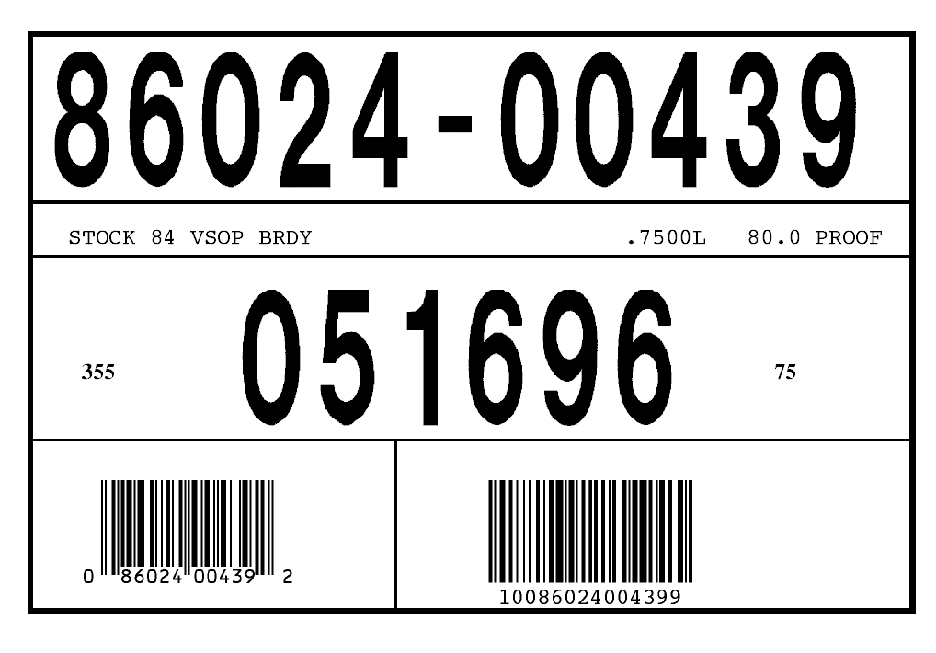

Example of Label for Special Order Brand Codes
975363 AK BLUEBERRY VODKA
0.750 L 12 units

