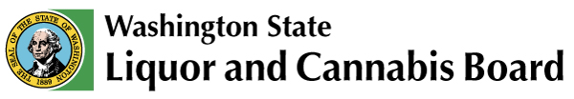 | Licensing & Regulation  1025 Union Ave SE  PO Box 43098  Olympia, WA 98504-3098  Phone: 360-664-1600  Fax: 360-753-2710  www.lcb.wa.gov
 |  | License Number
 |  | Trade Name
 |  | UBI Number

Beer and/or Wine Restaurant Food Service Acknowledgment

I understand that in order to obtain and maintain a beer and/or wine restaurant liquor license, I must meet the definition of a restaurant as outlined in RCW 66.04.010(38) where, with special space and accommodations, in consideration of payment, food, without lodgings is routinely furnished to the public.

To meet this definition I must do the following:

- Be open to the public at least five hours a day, three days a week as stated in
WAC 314-02-045(b).

- Provide minimum food service: menu items such as sandwiches, salads, soups, pizza, hamburgers, fries, savory pies, tacos, dumplings, fried rice, and/or other similar items are available to order as stated in WAC 314-02-010.
  - Menu items that consist solely of the following types of food do not qualify as minimum food service: precooked frozen meals that are reheated, carry-out items obtained from another business, or snack foods.

- Maintain the kitchen equipment necessary to support the menu.

I certify by my signature below that I currently meet and will continue to maintain the above requirements as long as I/we hold a Beer and/or Wine Restaurant liquor license.

Print Name | *
Signature | (*If you are printing this form select your title: Corporate President, Corporate Vice President, Corporate Secretary, Corporate Treasurer, Corporate Shareholder, LLC Member/Manager, Sole Proprietor, Partner or Spouse.)
Date

