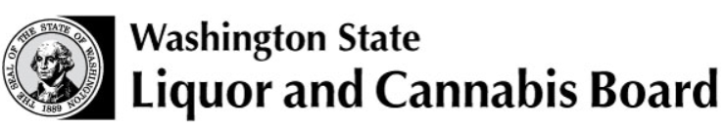

Individual Importation and Declaration of Alcoholic Beverages in Excess of the Duty Free Imported Liquor under Federal Law (RCW 66.12.110, WAC 314-68)

Permission by the U.S. Customs and Border Protection (CBP) to bring into the state of Washington the following alcoholic beverages is contingent upon payment of the Washington State taxes listed below within ten (10) calendar days from the date of this declaration.

Personal check payment may be made directly to the: WSLCB Finance Division
PO Box 43085
Olympia WA 98504-3085

Once your payment is sent to the Liquor and Cannabis Board, you are authorized to use alcoholic beverages for personal or household purposes, but not for sale or resale.

Mark this box if you wish to be sent a copy of the release form.

Group | Size | Qty | Rate | Subtotal |  | Group | Size | Qty | Rate | Subtotal
 | 375ml |  | $2.85 |  |  |  | 375ml |  | $0.09
SPIRITS | 750ml |  | $5.69 |  |  | WINE | 750ml |  | $0.17
 | 1.75L |  | $13.28 |  |  |  | 1.5L |  | $0.34
other size |  |  | @ $7.59 per liter |  |  | other size |  |  | @ $0.23 per liter
 |  |  | Total |  |  |  |  |  | Total
Group | Size | Qty | Rate | Subtotal |  | Group | Size | Qty | Rate | Subtotal
 | 750ml |  | $0.06 |  |  |  | 12oz |  | $0.07
CIDER | 6-pack of 12oz units |  | $0.17 |  |  | BEER | 6-pack of 12oz units |  | $0.43
other size |  |  | @ $0.08 per liter |  |  | other size |  |  | @ $0.20 per liter
 |  |  | Total |  |  |  |  |  | Total
Conversion Legend
355ml bottle = 12 oz  1 oz = .02957 Liters  1 Liter = 33.814 oz |  | TOTAL TAXES DUE WSLCB $

Port of Entry |  | Car/plate number, Vessel, or Flight No. |  | U.S. CBP Officer

I hereby certify that the alcoholic beverages listed herein are for personal or household use not to be sold or resold. I also agree to make payment of the above amount to the Washington State Liquor and Cannabis Board within ten (10) calendar days, and to act as custodian for the alcoholic beverages, until I receive a release from the Board.

PLEASE PRINT:
Applicant’s Name: |  |  |  |  |  | Date:
Address: | (Street) |  |  |  |  | Telephone:
 | (City) |  | (State) |  |  | (Zip Code)
Identification: | Document
 | Number
 |  |  |  |  |  | ^{Applicant’s Signature}

U.S. CBP: | WHITE copy to WSLCB by mail, fax 360-664-3208, or scan and e-mail to accountspayable@lcb.wa.gov  Keep CANARY copy for your records or destroy |  | Applicant: | Send PINK copy with remittance to the Washington State Liquor and Cannabis Board  Keep GOLDENROD copy for your records.

