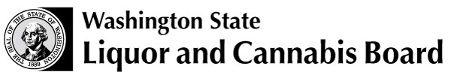 | Licensing and Regulation  PO Box 43098  Olympia, WA 98504-3098  Phone (360) 664-1600  Fax (360) 753-2710  www.lcb.wa.gov
 |  |  | License Number
 |  |  | Trade Name
 |  |  | UBI Number

Beer and Wine Theater License Acknowledgment

I understand that in order to obtain and maintain a Beer and Wine Theater License, I must meet the following requirements as outlined in WAC 314-02-082.

- A theater is a place of business where motion pictures or other primarily non-participatory entertainment such as text messaging to a movie screen, skits, and comedy shows are shown.

- This license may be issued only to theaters that have a maximum of four (4) screens/rooms.

- All alcoholic beverages must be sold by the individual drink and consumed on theater premises.

- The maximum serving size for beer is 12 oz. and for wine it is 5 oz.

- Alcohol may only be sold, served, or consumed in areas approved by the Liquor Control Board.

- All employees involved in the sale, service and/or supervision of alcoholic beverages will be required to attend Mandatory Alcohol Server Training (MAST) and obtain the appropriate permit for their level of service.

- Sufficient lighting must be maintained at the point of sale so that identification can be confirmed and patrons observed for signs of intoxication.

- If the theater premises will be frequented by minors, a copy of the signed Alcohol Control Plan Agreement must be prominently posted on the premises prior to minors being allowed entry.

- Penalties are doubled for a violation involving minors or the failure to follow the Alcohol Control Plan Agreement.

I certify under penalty of perjury under the laws of the State of Washington that I currently meet, and will continue to comply with all the requirements of this license.
Print Name |  | Title
Signature [Corporate officer, LLC member/manager, sole proprietor, partner] |  | Date

