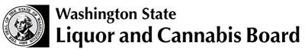 | Licensing and Regulation  1025 Union Ave SE  PO Box 43098  Olympia WA 98504-3098  Phone – (360) 664-1600  Fax – (360) 753-2710
 |  | License Number
 |  | Trade Name
 |  | UBI Number

GROWLERS ENDORSEMENT ACKNOWLEDGMENT FORM

Please sign below that you have read and understand all of the below requirements:

To qualify to sell growlers at my beer/wine specialty shop (permits the sale of beer to a purchaser in a sanitary container brought to the premises by the purchaser, or provided by the licensee or manufacturer, and filled at the tap by the licensee at the time of sale.)

Over fifty percent of my gross sales must be in beer and/or wine sales;

OR

I am required to maintain a beer and/or wine alcohol inventory that exceeds fifteen thousand dollars.

CERTIFICATION | I certify by my signature below that I have read and understand the requirements stated above. I further certify that I will continue to meet all requirements as long as this endorsement is on my license.

Print Name: |  |  | Title
Signature |  |  | Date

